**HW19 - UNIT TEST INDIVIDUAL TABLE**

**DATE: 09th february 2021**

1 ALMACHE LITARDO ANDERSON MOISES 10

**Pythagoras Theorem**

**Calculate the hypotenuse:**

**H^2=a^2+b^2**

| **A** | **B** | **Expected Result** | **Actual Result** |
| --- | --- | --- | --- |
| 3 | 4 | 25 |  |
| 7.69 | 18.15 | 19.71 |  |
| 6 | 8 | 10 |  |
| 7 | 5 | 8.60 |  |
| 6.2 | 4.4 | 7.602 |  |
| -13.5 | -9.7 | 16.623 |  |
| 10.2 | 14.8 | 17.974 |  |
| 20.3 | 15.8 | 25.724 |  |
| 17 | 10 | 19.72 |  |
| -47 | -56 | 73.109 |  |

2 ALTAMIRANO BENALCAZAR CRISTHIAN ALEXANDER 9/10

**Perimeter of a rectangle**

**P= 2*b + 2*h**

| **2(base)** | **2(height)** | **Expected Result** | **Actual Result** |
| --- | --- | --- | --- |
| 10.2 | 6.5 | 33.4 |  |
| 7.5 | 8.3 | 31.6 |  |
| 19.7 | 13.4 | 66.2 |  |
| 17.2 | 12.5 | 59.4 |  |
| 20.3 | 15.6 | 71.8 |  |
| 23.5 | 19.7 | 86.4 |  |
| 28.1 | 20.8 | 97.8 |  |
| 12.3 | 9.8 | 44.2 |  |
| 100.5 | 89.7 | 380.4 |  |
| 500.8 | 300.9 | 1603.4 |  |

3 ALVAREZ RAMIREZ MICHELLE ESTEFANIA 10

**Voltage calculation (Ohm's law )**

$Voltage= Intensity * Resistance$

| Intensity | Resistance | Expected Result | Actual Result |
| --- | --- | --- | --- |
| 6 | 0 | 0 |  |
| 2,3 | 20 | 46 |  |
| 10 | 8 | 80 |  |
| 200 | 9,8 | 1960 |  |
| 0 | 15 | 0 |  |
| -5,7 | 23 | -131,10 |  |
| 20 | 5000 | 100000 |  |
| 0 | 0 | 0 |  |
| -9,6 | 5,2 | -49,92 |  |
| 25 | 15 | 375 |  |

4 ANDRADE CARATE ALAN DAMIAN 7

equation of time t=d/v

| distance | speed | time |
| --- | --- | --- |
| 100m | 35 m/s | **2.85 s** |
| 50m | 40 m/s | **1.25 s** |
| 25m | 50 m/s | **0.5 s** |
| 10m | 5 m/s | **2 s** |
| 5m | 10 m/s | **0.5 s** |
| 1m | 10 m/s | **0.1 s** |

5 ANDRANGO ESPINOSA ALEX PAUL 10

***Linear momentum***

***p=m*v***

| m(mass) | v(speed) | Expected result  P (linearMomentum) | Actual Result |
| --- | --- | --- | --- |
| 3.0 | 4.0 | 12.0 |  |
| 8.0 | 5.0 | 40.0 |  |
| -10.4 | -20.9 | 217.36 |  |
| 710.7 | 113.2 | 8045.24 |  |
| 3001.0 | 680.8 | 2043080.8 |  |
| 4.137 | 59.14 | 244.66218 |  |
| -39.18 | 1.11 | -43.4898 |  |
| 0.01 | 0.01 | 0.0001 |  |
| 500.1 | 0.0 | 0 |  |
| 0.0 | 415.1 | 0 |  |

6 ARROBA SOLORZANO CRISTIAN ALEXANDER

**TEOREMA DE STEWART**

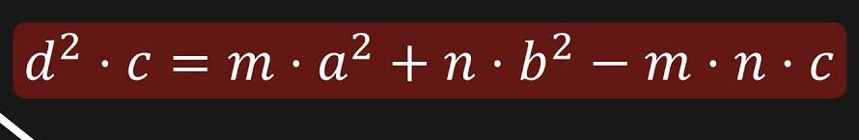

7 ASUMAZA GUALOTO DYLAN ALEXANDER 9

**Area of ​​a regular polygon**

$A=P *a/2$

| P(perimeter) | a(apothem) | $A=P *a/2$ | Actual Result |
| --- | --- | --- | --- |
| 30 | 4.1 | 61.5 |  |
| 25 | 3.4 | 42.5 |  |
| 28 | 2.2 | 30.8 |  |
| 10 | 3.2 | 16 |  |
| 25 | 7.7 | 96.25 |  |
| 40 | 8.3 | 166 |  |
| 33 | 4,4 | 72.2 |  |
| 50 | 3,3 | 82.5 |  |
| 44 | 2.6 | 57.2 |  |

8 BRAVO RODRIGUEZ KATHERIN DAYANNE 7

**Formula for Work**

**Formula:**

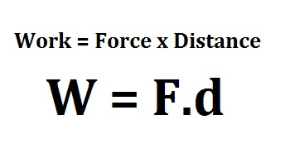

| **Number** | **Force (newtons)** | **Distance (meters)** | **Expected result**  **work (joules)** | **Actual result** |
| --- | --- | --- | --- | --- |
| **1** | 72 N | 14 m | 1008 J |  |
| **2** | 80 N | 20 m | 1600 J |  |
| **3** | 120 N | 16 m | 1920 J |  |
| **4** | 15 N | 9 m | 135 J |  |
| **5** | 30 N | 6 m | 180 J |  |
| **6** | 50 N | 26 m | 1300 J |  |
| **7** | 65 N | 35 m | 2275 J |  |
| **8** | 8 N | 2 m | 16 J |  |
| **9** | 63 N | 23 m | 1449 J |  |
| **10** | 120 N | 85 m | 10200 J |  |

9 BRAVO VILLALOBOS CHRISTIAN DAVID 0

10 BUSTILLOS MONTENEGRO PABLO SEBASTIAN 7

**mechanical energy**

$E_{m}=E_{c}+E_{+p}$

| **Kinetic energy** | potential energy  potentialEnergy | Result |
| --- | --- | --- |
| 100 J | 5880 J | 5980 J |
| 75 J | 451 J | 526 J |
| 452 J | 35 J | 487 J |
| 446 J | 741 J | 1187 J |
| 32174 J | 456 J | 32630 J |
| 3124 J | 741 J | 3865 J |
| 214 J | 45 J | 259 J |
| 123 J | 741 J | 864 J |
| 745 J | 842 J | 1587 J |

11 CADENA ROMAN BENJAMIN ABEL 0

12 CAISATOA RAMIREZ SEBASTIAN BERNARDO 10

**Distance between two points**

| **pointA**  **(x1,y1,z1)** | **pointB**  **(x2,y2,z2)** | **Result** |
| --- | --- | --- |
| **(-1,0,4)** | **(1,-2,-3)** | **7,54** |
| **(3,4,2)** | **(2,5,4)** | **2,44** |
| **(4,-2,1)** | **(-4,-3,-7)** | **11,35** |
| **(-3,-6,-5)** | **(4,6,9)** | **19,72** |
| **(4,6,3)** | **(-7,5,6)** | **11,44** |
| **(9,4,5)** | **(4,-6,-2)** | **13,19** |
| **(2,4,1)** | **(3,2,4)** | **3,74** |
| **(5,8,2)** | **(8,7,4)** | **3,74** |
| **(2,-9,-4)** | **(6,7,4)** | **18,33** |

13 CALDERON MERCHAN ANDY JOSUE 8

**ACCELERATION FORMULA**

| **F(force)** | **M(mass)** | **acceleration (m**/ $s^{2}$**)** |
| --- | --- | --- |
| 50N | 110Kg | 0,45 |
| 100N | 90Kg | 1,22 m/ $s^{2}$ |
| 20N | 50Kg | 0,4 m/ $s^{2}$ |
| 220N | 70Kg | 3,14 m/ $s^{2}$ |
| 500N | 60Kg | 8,33 m/ $s^{2}$ |
| 25N | 5Kg | 5 m/ $s^{2}$ |
| 350N | 25Kg | 14 m/ $s^{2}$ |
| 700N | 550Kg | 1,27 m/ $s^{2}$ |
| 30N | 0,15 Kg | 200 m/ $s^{2}$ |

14 CORREA RUIZ KERLY YADIRA 10

pressure

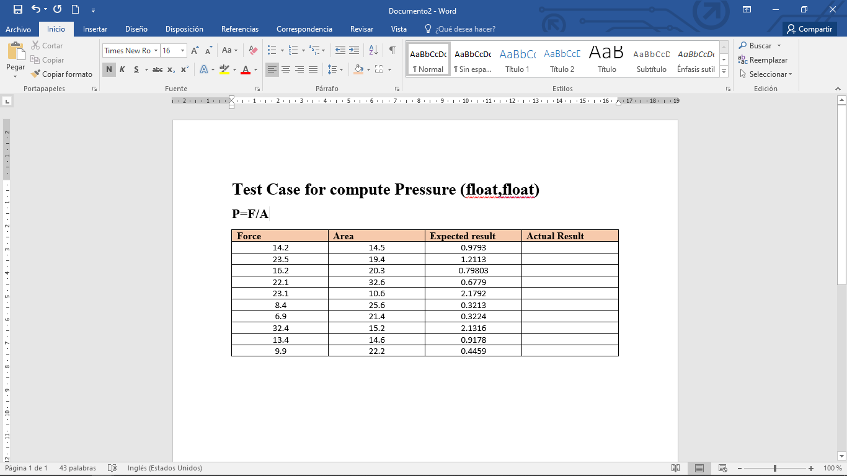

| **force** | **area** | **Expected result** | **Actual Result** |
| --- | --- | --- | --- |
| 14.2 | 14.5 | 0.9793 |  |
| 23.5 | 19.4 | 1.2113 |  |
| 16.2 | 20.3 | 0.79803 |  |
| 22.1 | 32.6 | 0.6779 |  |
| 23.1 | 10.6 | 2.1792 |  |
| 8.4 | 25.6 | 0.3213 |  |
| 6.9 | 21.4 | 0.3224 |  |
| 32.4 | 15.2 | 2.1316 |  |
| 13.4 | 14.6 | 0.9178 |  |
| 9.9 | 22.2 | 0.4459 |  |

15 CRUZ PANTOJA DARLING MICAELA 8

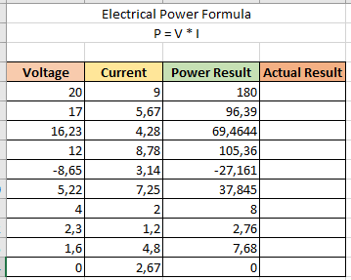

16 DE LA CRUZ QUINGA ALEJANDRO 10

SEBASTIAN

**Triangle Area**

| **base** | **height** | **Area (expected result)** | **Actual result** |
| --- | --- | --- | --- |
| **4.56** | 852.22 | 1943.06 |  |
| **40485.2** | 52.00 | 1052615.2 |  |
| **523.20** | 526.3 | 137680.08 |  |
| **-4502.05** | 2589.00 | -5827903.725 |  |
| **4528280.63** | -98524.4 | -2.2307 * 10(-11) |  |
| **545698.0** | -0.25896 | -70656.97704 |  |
| **54365.52** | 20.5 | 557246.58 |  |
| **-98505.36** | -98752.55 | 4863827744 |  |
| **-9875.00** | 0.2582 | -1274.8625 |  |
| **8582.528** | 28.00 | 120155.392 |  |

17 EIVAR DAGUA JAIME MAURICIO 10

**CALCULATION OF FORCE**

**F=mxa**

| **mass(Kg)** | **acceleration(m/s^2)** | **Force=mxa(N)** |
| --- | --- | --- |
| **89** | **9,9** | **88,11** |
| **78** | **12** | **936** |
| **1** | **18** | **18** |
| **0,000000789** | **0** | **0** |
| **935134,98943** | **-2** | **-1870269,979** |
| **11** | **98641,123** | **1085052,353** |
| **98962** | **98** | **9698276** |
| **1000000** | **1000** | **1000000000** |
| **123456** | **64211,12** | **7927248031** |

18 GARCIA BARRETO MAYERLY PRISSILLA 9

$A=π* r^{2}$

where

$π$ = 3.1415

r = radius

A = area

**Circle Area**

| $π$ XXXXXXXX | radio | $A=π* r^{2}$ |
| --- | --- | --- |
| **3.1415** | **2** | **12.566** |
| **3.1415** | **1** | **3.1415** |
| **3.1415** | **0.5** | **0.7853** |
| **3.1415** | **8** | **20.,056** |
| **3.1415** | **16** | **804.224** |
| **3.1415** | **4** | **50.264** |
| **3.1415** | **1,54** | **7.45** |
| **3.1415** | **5** | **78.5375** |
| **3.1415** | **6** | **113.094** |

19 GOMEZ DIAZ MELISSA MALAYCA 7

SECTOR OF A CIRCLE

$A=\frac{π*r^{2 }*α°}{360°}$

| **Radius (R)** | **Angle ($α°$)** | $A=\frac{π*r^{2 }*α°}{360°}$ |
| --- | --- | --- |
| 1 | 30° | $0.262 m^{2 }$ |
| 24 | 42° | $211.12 m^{2 }$ |
| 60 | 94° | $2953.1 m^{2 }$ |
| 15 | 43° | $84.43 m^{2 }$ |
| 8 | 16° | $8.94 m^{2 }$ |
| 32 | 129° | $1152.76 m^{2 }$ |
| 45 | 335° | $5919.94 m^{2 }$ |
| 19 | 36° | $113.41 m^{2 }$ |
| 5 | 50° | $10.91 m^{2 }$ |
| 26 | 120° | $707.91 m^{2 }$ |

20 GUAMAN VEJARANO ANGEL DAVID 10

**Calculation of Distance of a projectile**

| **Time [second]** | **Speed[m/s]** | **=Distance [m] [v*t]** | **Expected Result** | **Actual Result** |
| --- | --- | --- | --- | --- |
| **10000 [s]** | **3.248 [m/s]** | **3248 [m]** | **3248** |  |
| **1050 [s]** | **25.8 [m/s]** | **27090 [m]** | **27090** |  |
| **400[s]** | **60.900 [m/s]** | **24360 [m]** | **24360** |  |
| **100 [s]** | **72.584 [m/s]** | **7258.4 [m]** | **7258.4** |  |
| **80 [s]** | **-25.25 [m/s]** | **-2020 [m]** | **-2020** |  |
| **40 [s]** | **10.20 [m/s]** | **408 [m]** | **408** |  |
| **10 [s]** | **9.81 [m/s]** | **98.1 [m]** | **98.1** |  |
| **-20 [s]** | **-14.56 [m/s]** | **291.2 [m]** | **291.2** |  |
| **-22.25255 [s]** | **-25.852 [m/s]** | **575.2729226 [m]** | **575.2729226** |  |
| **-42.2558 [s]** | **-0.1 [m/s]** | **4.22558 [m]** | **4.22558** |  |

21 GUITARRA SANCHEZ JHON ALEXANDER 7

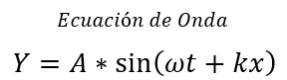

|  | t(s) | x(m) | Expected Result | Actual Result |
| --- | --- | --- | --- | --- |
| 1 | 22 | 17 | 1.30062148 |  |
| 2 | 0 | 74 | -0.609850917 |  |
| 3 | 59 | 8 | 0.438850517 |  |
| 4 | 48 | -99 | -1.430005777 |  |
| 5 | 23 | 40 | 1.787939296 |  |
| 6 | 33 | -22 | -0.352210587 |  |
| 7 | 5 | -34 | -1.976081844 |  |
| 8 | 46 | 37 | -1.976044645 |  |
| 9 | 6 | 84 | 1.366303308 |  |
| 10 | 60 | -100 | -1.860079009 |  |

22 GUZMAN LOPEZ JOSE DAVID 8

**Einstein Equation E=mc2**

| Mass (kg) | c 2 (m/s) | Expected Result (J) | Actual Result |
| --- | --- | --- | --- |
| 9.109 x 10-28 | (3x 108) 2 | 8.1981x 10-11 |  |
| 9.11 x 10-31 | (3x 108) 2 | 8.1990x 10-14 |  |
| 0 | (3x 108) 2 | 0 |  |
| 1 | (3x 108) 2 | 9.0000x 1016 |  |
| 10 | (3x 108) 2 | 9.0000x 1017 |  |
| 25 | (3x 108) 2 | 2.2500x 1018 |  |
| 50 | (3x 108) 2 | 4.5000x 1018 |  |
| 100 | (3x 108) 2 | 9.0000x 1018 |  |
| 1000 | (3x 108) 2 | 9.0000x 1019 |  |
| 1857 | (3x 108) 2 | 1.6713x 1020 |  |

23 INSUASTI LOPEZ JONATHAN ESTEBA 10

**Volume of the spherical sector with 2 bases**

$v=\frac{πh(3{r1}^{2}+3{r2}^{2}h^{2})}{6}$

| **r1** | **r2** | **h** | **Expected Result** | **Actual Result** |
| --- | --- | --- | --- | --- |
| **2** | **3** | **1.5** | **57.1377** |  |
| **3** | **4** | **2** | **229.3362** |  |
| **0.4** | **0.6** | **1** | **0.8168** |  |
| **0.6** | **1.2** | **5** | **285.5707** |  |
| **54** | **23** | **19** | **5786523.071** |  |
| **11** | **2** | **5** | **1735.7299** |  |
| **200** | **93** | **121** | **2.40757 ${x10}^{10}$** |  |
| **0.1** | **2** | **0.5** | **0.7932** |  |
| **15** | **4** | **7** | **11094.5344** |  |
| **13342** | **3412** | **654** | **5.11548 ${x10}^{15}$** |  |

24 LANDAZURI SEGOVIA MATEO ISRAEL

**AREA OF THE RECTANGLE**

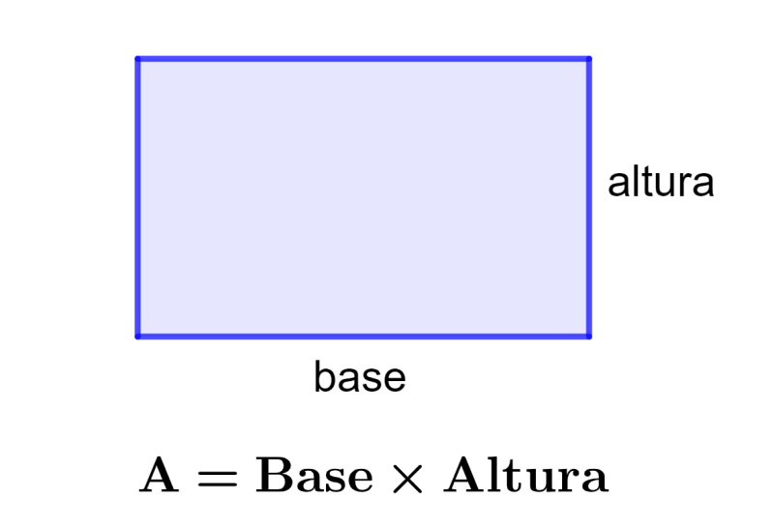

| BASE | HEIGHT | Expected Result | Actual Result |
| --- | --- | --- | --- |
| **1.2** | **0.80** | **0.96** |  |
| **4.5** | **3.75** | **16.875** |  |
| **5.6** | **4.49** | **25.144** |  |
| **7.8** | **6.68** | **52.104** |  |
| **20.1** | **10.2** | **205.02** |  |

25 LINCANGO CRIOLLO JOSE DANIEL 10

**Calculate the speed**

| DISTANCE**(m)** | WEATHER**(s)** | Operation | Expected Result **(m/s)** | Actual Result |
| --- | --- | --- | --- | --- |
| 10.5 | 5 | 10/5 | 2.1 |  |
| 8.3 | 2.7 | 8/2 | 3.07 |  |
| 16.4 | 8.9 | 16/8 | 1.84 |  |
| 20.1 | 7 | 20/12 | 2.87 |  |
| 13 | 4 | 13/4 | 3.25 |  |
| 23 | 11.5 | 23/11 | 2 |  |
| 14.2 | 9 | 14.2/9 | 1.55 |  |
| 60.5 | 20.3 | 60.5/20.3 | 2.9 |  |
| 50.6 | 6.6 | 50.6/6.6 | 7.66 |  |

26 MAISINCHO PAUCAR RICHAR ALEXANDER 6

**Parallel Resistors**

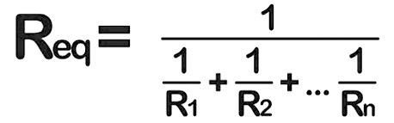

| **R1 (ohm)** | **R2(ohm)** | **Rt (ohm)** |
| --- | --- | --- |
| **10.2** | **15** | **6.07** |
| **20** | **40.6** | **4.6** |
| **13** | **2** | **1.733** |
| **100** | **500** | **83.33333** |
| **200** | **200** | **100** |
| **25** | **10** | **7.14** |

27 MALDONADO BASTIDAS MATEO STEFANO 10

**Volume of a cone**

| Radio(r) | Height(h) | $π$ | V= $(π$ $* r^{2}$ $* h$) / 3 | Expected Result |
| --- | --- | --- | --- | --- |
| 1.5 | 4.7 | 3.1416 | $(3.1416)(1{.5)}^{2}(4.7)/3$ | 4.188 |
| 3.5 | 2.8 | 3.1416 | $(3.1416)(3{.5)}^{2}(2.8)/3$ | 37.699 |
| 2 | 5.6 | 3.1416 | $(3.1416)(2)(5.6)/3$ | 23.457 |
| 5.5 | 6 | 3.1416 | $(3.1416)(5{.5)}^{2}(6)/3$ | 190.066 |
| 7 | 3.56 | 3.1416 | $(3.1416)(7)^{2}(3.56)/3$ | 182.673 |
| 4 | 8 | 3.1416 | $(3.1416)(4)^{2}(8)/3$ | 134.041 |
| 2.4 | 3 | 3.1416 | $(3.1416)(2.4)^{2}(3)/3$ | 15.566 |
| 6 | 4 | 3.1416 | $(3.1416)(6)^{2}(4)/3$ | 150.796 |

28 MANTUANO FERNANDEZ LEONEL FERNANDO 1

**Volumen de una esfera**

29 MORALES CAICEDO ANTHONY JAVIER 5

**Quadratic equation**

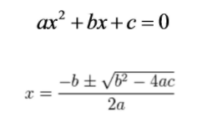

| **Equation** | **Value of a** | **Value of b** | **Value of c** | **Expected result** | **Actual result** |
| --- | --- | --- | --- | --- | --- |
| $x^{2}+2x-63=0$ | 1 | 2 | -63 | $x_{1}=7$.21 $x_{2}=-9$ .23 |  |
| $7x^{2}-13x-1=0$ | 7 | -13 | -1 | $x_{1}=$ $\frac{13+\sqrt{197}}{4}$ $x_{2}=$ $\frac{13-\sqrt{197}}{4}$ |  |
| $5x^{2}+12x=0$ | 5 | 12 | 0 | $x_{1}=0$ $x_{2}=-2.4$ |  |
| $6x^{2}-19x+10=0$ | 6 | -19 | 10 | $x_{1}=2.5$ $x_{2}=0.66$ |  |
| $x^{2}+7x=0$ | 1 | 7 | 0 | $x_{1}=0$ $x_{2}=-7$.1 |  |

30 PALACIOS CANDO DIEGO SEBASTIAN 10

**Calculation percentage of budget execution = Total Executed/Total Budget**

| Butget | Executed | Expected Result | Actual Result |
| --- | --- | --- | --- |
| 5.000,00 | 4.870,00 | 97,40% |  |
| 1.000.000,00 | 805.000,00 | 80,50% |  |
| 70.000,00 | 20.000,00 | 28,57% |  |
| 15.000,00 | 12.000,00 | 80,00% |  |
| 4.500.000,00 | 4.200.000,00 | 93,33% |  |
| 30.000,00 | 5.000,00 | 16,67% |  |
| 500.000,00 | 650.000,00 | 130,00% |  |
| 2.670.000,00 | 1.500.000,00 | 56,18% |  |
| 7.000,00 | 2.500,00 | 35,71% |  |
| 9.000.000,00 | 5.000.000,00 | 55,56% |  |

31 PAUCAR LEMA ALEX JAVIER 9

**Volume of a cylinder**

| Radio(r) | Height(h) | $π$ | V= $π*r^{2}*h$ | Expected Result |
| --- | --- | --- | --- | --- |
| 1 | 4 | 3.1416 | $(3.1416)(1)^{2}(4)$ | 12.566 |
| 2 | 2 | 3.1416 | $(3.1416)(2)^{2}(2)$ | 25.132 |
| 8 | 4 | 3.1416 | $(3.1416)(8)^{2}(4)$ | 804.249 |
| 12 | 6 | 3.1416 | $(3.1416)(12)^{2}(6)$ | 2714.324 |
| 4 | 2 | 3.1416 | $(3.1416)(4)^{2}(2)$ | 100.531 |
| 0.5 | 3 | 3.1416 | $(3.1416)(0.5)^{2}(3)$ | 2.356 |
| 1.2 | 9 | 3.1416 | $(3.1416)(1.2)^{2}(9)$ | 40.715 |
| 9 | 5.5 | 3.1416 | $(3.1416)(9)^{2}(5.5)$ | 1399.582 |
| 10 | 3 | 3.1416 | $(3.1416)(1{0)}^{2}(3)$ | 942.48 |

32 QUINGA GUAYASAMIN LEANDRO ALEXANDER 9

CALCULATE WEIGHT

| Masa(m) | Gravedad(g) | P = m . g | Expected Result | Actual Result |
| --- | --- | --- | --- | --- |
| 6 Kg | 9.81 m/s | 6*9.81 | 58.86 |  |
| 159 Kg | 9.81 m/s | 159*9.81 | 1559.79 |  |
| -19.34 Kg | 9.81 m/s | -19.34*9.81 | -189.7254 |  |
| 19735.335 Kg | 9.81 m/s | 19735.335*9.81 | 193603.63635 |  |
| 1.889 Kg | 9.81 m/s | 1.889*9.81 | 18.53109 |  |
| -173.638 Kg | 9.81 m/s | -173.638*9.81 | -1703,38878 |  |
| 0 | 9.81 m/s | 0*9.81 | 0 |  |
| -0.17729kg | 9.81 m/s | -0.17729*9.81 | -1,7392149 |  |
| 0.17729kg | 9.81 m/s | 0.17729*9.81 | 1.7392149 |  |

33 RUANO PONCE ALEXANDER JAVIER 10

Area of ​​a Triangle

| B | h | (B * h)/2  Expected Result | Actual result |
| --- | --- | --- | --- |
| 4.56 | 852.22 | 1943.06 |  |
| 40485.2 | 52.00 | 1052615.2 |  |
| 523.20 | 526.3 | 137680.08 |  |
| -4502.05 | 2589.00 | -5827903.725 |  |
| 4528280.63 | -98524.4 | -2.2307 * 10(-11) |  |
| 545698.0 | -0.25896 | -70656.97704 |  |
| 54365.52 | 20.5 | 557246.58 |  |
| -98505.36 | -98752.55 | 4863827744 |  |
| -9875.00 | 0.2582 | -1274.8625 |  |
| 8582.528 | 28.00 | 120155.392 |  |

34 SALTOS TACO PAUL ALEXANDER 10

**Area of ​​a rhombus**

**Área=(Diagonal Mayor *Diagonal Menor)/2**

**Área= $(D*d)/2$**

| **D** | **d** | $(D*d)/2$ | **Expected Result** | **Actual Result** |
| --- | --- | --- | --- | --- |
| 16.2 | 12.2 | $(16.2*12.2)/2$ | 96.4 |  |
| 10.07 | 7.93 | $(10.07*7.93)/2$ | 39.92755 |  |
| 6.8 | 4.2 | $(6.8*4.2)/2$ | 14.28000 |  |
| -15.42 | 6.37 | $(-15.42*6.37)/2$ | -49.1127 |  |
| 32.1406 | 9.8356 | $(32.1406*9.8356)/2$ | 158.0610427 |  |
| 8.2 | 6.2 | $(8.2*6.2)/2$ | 24.4 |  |
| 12.6894 | -3.4598 | $(12.6894*-3.4598)/2$ | -21.95139306 |  |
| 17.5485 | 1.2458 | $(17.5485*1.2458)/2$ | 10.93096065 |  |
| 2.4582 | 0.9845 | $(2.4582*0.9845)/2$ | 1.21004895 |  |
| 0.1404 | -24.0620 | $(0.1404*-24.0620)/2$ | -1.6891524 |  |

35 SANCHEZ MISHQUERO JOSE FRANCISCO 10

hypotenuse

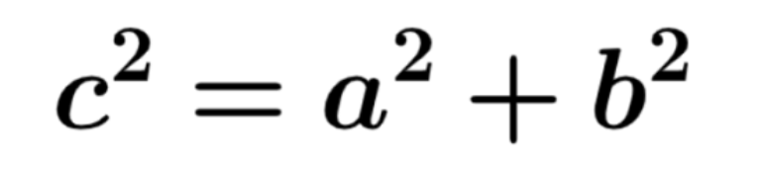

| a | b | Expected Result | Actual Result |
| --- | --- | --- | --- |
| 6 | 0 | 6 |  |
| 2,3 | 20 | 20.13 |  |
| 10 | 9 | 13,45 |  |
| 100.0 | 8.00 | 100,32 |  |
| 5.876 | 126.9787 | 127.11 |  |
| -6.0 | 23 | -16,16 |  |
| 20.00 | 5 | 20.62 |  |
| 0 | 0 | 0 |  |
| -9.0 | 5.2 | 10,39 |  |
| 1 | 1 | 1,41 |  |

36 SHUGULI REINOSO ALAN JESITH 7

**Circle Perimeter**

**P=2* π*r**

| 2 | π | r | Expected Result | Actual Result |
| --- | --- | --- | --- | --- |
| 2 | π | 2 | 4π |  |
| 2 | π | 4 | 8π |  |
| 2 | π | 6 | 12π |  |
| 2 | π | 8 | 16π |  |
| 2 | π | 9 | 18π |  |
| 2 | π | 13 | 26π |  |
| 2 | π | 11 | 22π |  |
| 2 | π | 10 | 20π |  |
| 2 | π | 12 | 24π |  |
| 2 | π | 17 | 34π |  |

37 SIMBAÑA SIMBAÑA JONATHAN GUSTAVO 5

Circumference of the circle

C= Pi*d

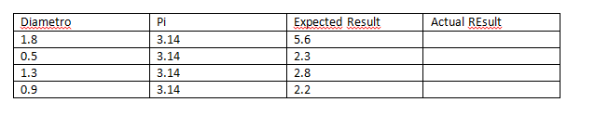

38 TAPIA ALBAN ANDREA JULIANNA 10

**Area of a sphere**

$A= 4π r^{2}$

| **Constant** | $π$ | $r$ | **Expected result** | **Actual result** |
| --- | --- | --- | --- | --- |
| 4 | 3.1416 | 2.1 | 55.42 |  |
| 4.5 | 245.5 |  |
| 6.9 | 452.39 |  |
| 8.8 | 804.25 |  |
| 10.4 | 1256.64 |  |
| 12.6 | 1809.56 |  |
| 14.5 | 2642.09 |  |
| 16.8 | 3546.74 |  |
| 18.9 | 4488.84 |  |
| 20.2 | 5127.59 |  |
| 22.4 | 6305.32 |  |

39 TAYO RUIZ SEBASTIAN ALEJANDRO 7

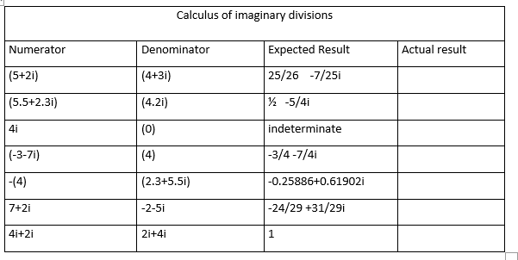

40 TECA TELLO CAMILA MILENA 10

**Test Cases for Perimeter of rhomboid (float, float)**



| **Constant** | **Side a** | **Side b** | **Expected Result** | **Actual Result** |
| --- | --- | --- | --- | --- |
| **2** | 12.3 | 10.9 | 46.4 |  |
| **2** | 4.05 | 6.99 | 22.08 |  |
| **2** | 7.841 | 6.059 | 27.8 |  |
| **2** | 11.09 | 9.85 | 41.88 |  |
| **2** | 2.0 | 4.7 | 13.4 |  |
| **2** | 10.115 | 10.99 | 42.21 |  |
| **2** | 5.07 | 4.0 | 18.14 |  |
| **2** | 2.2 | 4.0 | 12.4 |  |
| **2** | 15.7 | 17.09 | 65.58 |  |
| **2** | 4.5 | 4.0 | 17.0 |  |

41 TERAN FLORES MELANIE ELIZABETH 15

**Elipse Area**

A=a*b*π

| **Semi-minor axis (a)** | **Semi-major axis (b)** | **Expected result** | **Actual result** |
| --- | --- | --- | --- |
| 2 | 5 | 31.4159 |  |
| 5 | 7 | 109.9557 |  |
| 0.5 | 2.5 | 3.9269 |  |
| -2 | 7 | Error Message |  |
| 2 | 4 | 25.1327 |  |
| 0.125 | 1.579 | 0.6201 |  |
| 123 | 215 | 83079.4177 |  |
| 3 | -8 | Error Message |  |
| 12345 | 98765 | 3830399174 |  |
| -1 | -3 | Error Message |  |

42 VILLEGAS ESTRELLA SALMA ABIGAIL 10

**Density Formula**

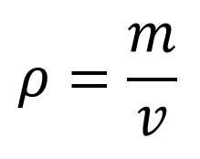

| **Case Number** | **Mass (g)** | **Volume (cm3)** | **Expected Result** | **Actual Result** |
| --- | --- | --- | --- | --- |
| **1** | 15.7 | 12 | **1.308333** |  |
| **2** | 10.6 | 8.01 | **1.325** |  |
| **3** | 8.3 | 15.2 | **0.53333** |  |
| **4** | 210.6 | 0.96 | **219.375000** |  |
| **5** | 0.36 | 18.3 | **0.019672** |  |
| **6** | 7.89 | 4.29 | **1.839161** |  |
| **7** | 17.5 | 10.13 | **1.75** |  |
| **8** | 200 | 6.32 | **31.645570** |  |
| **9** | 16 | 0.00007 | **228571.4286** |  |
| **10** | 0.0006 | 7.08 | **0.000847** |  |

43 ZEAS CLAVIJO JOEL ALEXANDER 10

**Calculation of amperage in an electrical circuit**

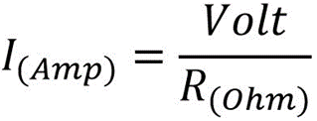

| **Voltage (v)** | **Resistance (ohm)** | **V/R** | **Expected resulted** | **Amperage (A)** |
| --- | --- | --- | --- | --- |
| 2 | -85 | 2**/**-85 | -0.0235 |  |
| 5.5 | 547 | 5.5**/**547 | 0.0100 |  |
| 0 | 186.5 | 0**/**186.5 | 0 |  |
| 158 | 0 | 158**/**0 | ?? // Error |  |
| 0.84 | 15.8 | 0.84**/**15.8 | 0.0531 |  |
| -1.20 | 848 | -1.20**/**848 | -0.0014 |  |
| 100.01 | 849.44 | 100.01**/**849.44 | 0.1177 |  |
| 0000.9 | -75 | 0000.9**/**-75 | -0.0120 |  |
| 85.75485 | 0.999 | 85.75485**/**0.999 | 85.8406 |  |
| 0.999 | 5884.98 | 0.999**/**5884.98 | 0.00016 |  |